# Publish for Submission User Guide

This exercise will go through the process of preparing a Unity Project so it can be submitted for evaluation.

## Table of Contents

Table of Contents

Publish for Submission User Guide 1

Table of Contents 1

Overview 1

Required 1

Activity Features 2

Creating an Executable Build 2

Running the Executable 5

Creating a Gameplay Video 7

Publishing Your Game for Submission 10

Uploading a Submission to a Learning Management System 12

# Overview

## Required

Unity 2020.3.x (LTS) or later

Learning Management System student account

Unity project

Publish For Submission package

The activity was tested on Unity 2020.3.16 version

And Publish for Submission 1.0.0 version

## Activity Features

* Creating an executable build
* Creating a gameplay video
* Adding Documentation to your project
* Publishing the game for submission
* Uploading the items to a Learning Management System

# Creating an Executable Build

An Executable (App on Mac OS) allows the user to run the application without having Unity installed.

Go to File and click on Build Settings.

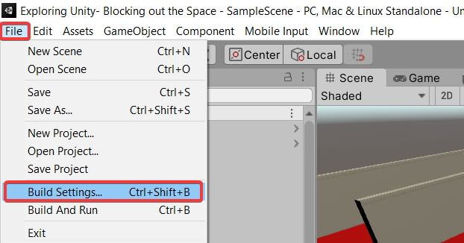

Click on the Add Open Scenes button to add our currently opened scene.

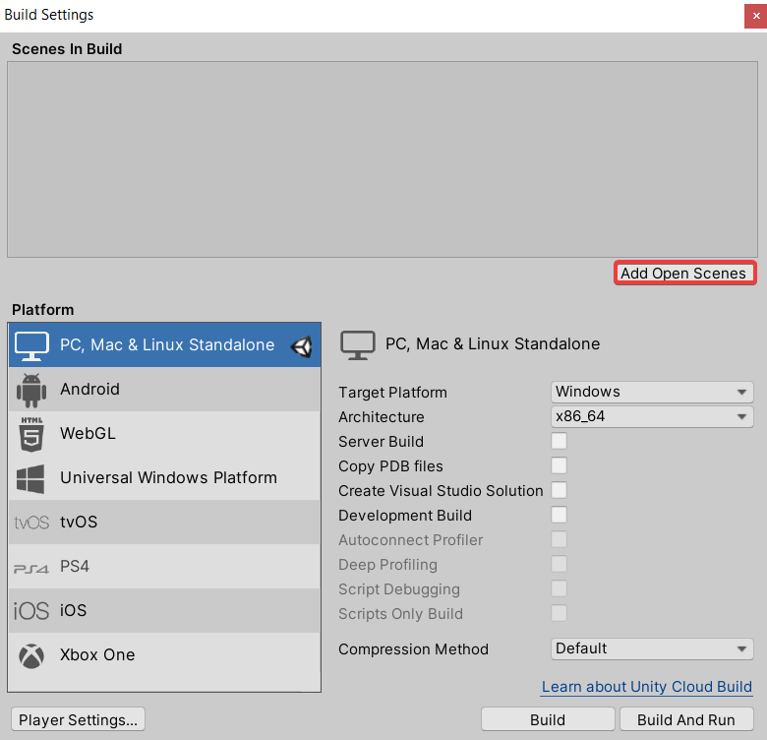

Click on Build.

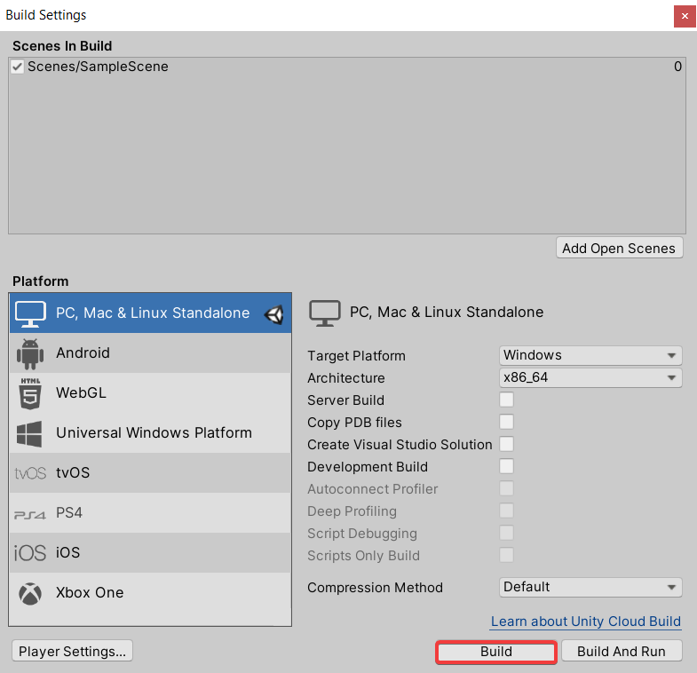

Select **New Folder** from the ribbon (or from the **File** menu in Mac OS).



Name the folder **Build**.



Double-click on the new folder to enter it, then press Select Folder.

On Mac OS, you will need to also enter the name of your application. Set this to **Gallery**.



## Running the Executable

To run the executable, you don’t need to have the Unity editor. Use the file explorer to navigate to where you store your Unity projects (e.g., **Desktop\Unity**). If you don’t remember, you can click on the three dots beside your project’s description in Unity Hub, then go into the **Build** folder.

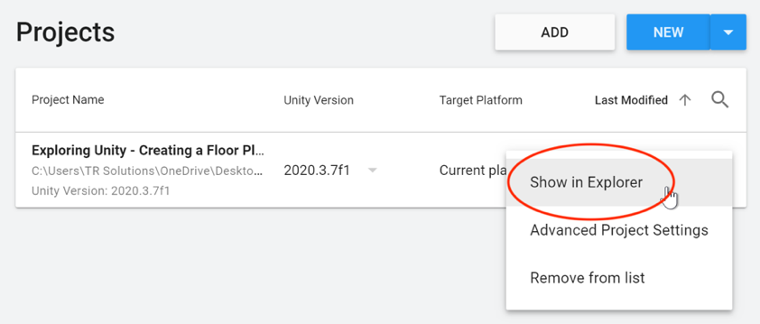

Your Build folder will look like this in Windows:

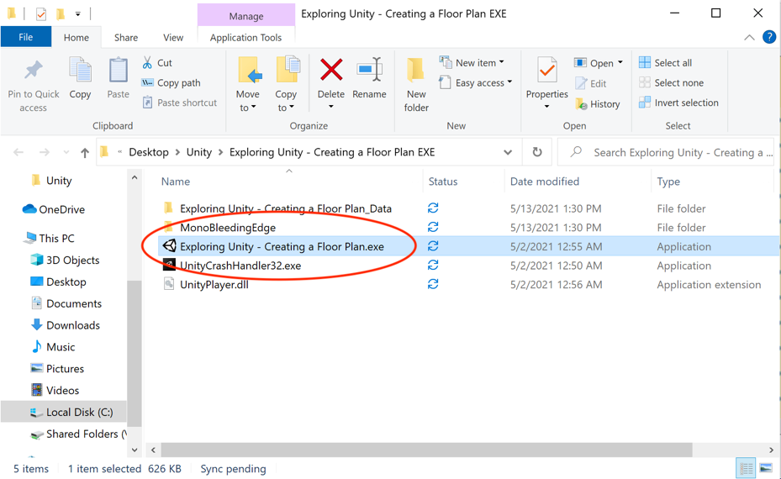

And like this in Mac OS:

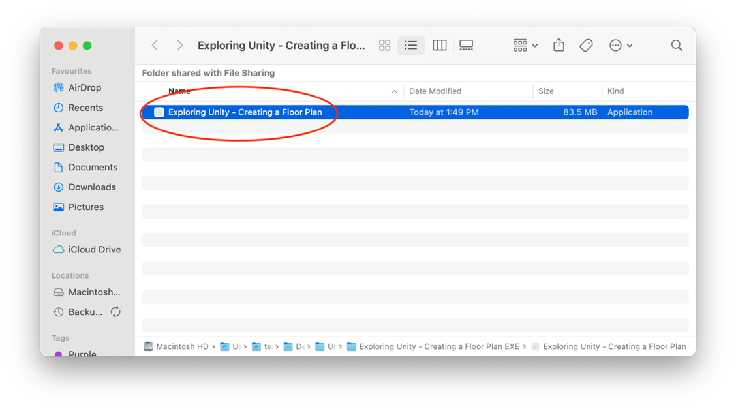

In Windows, you will see several files. In Mac OS, just one. Double-click on the shown file to run your executable.

In Windows, press ALT + F4 to force close it once you’re done playing. On the Mac, press ⌘ tab to switch away from the application, then use the Dock to close it.

# Creating a Gameplay Video

Unity allows you to create a gameplay video from within the editor. To record videos, you need to have the Unity Recorder package installed.

From the Window menu, open the Package Manager.

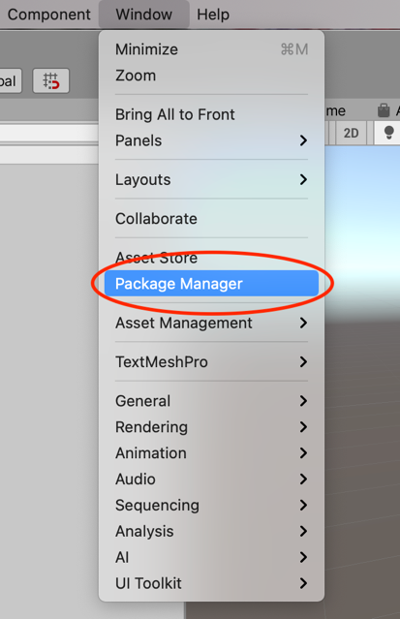

Unity will take some time to calculate the packages in your application. When it is done, select “Unity Registry” as the package list source:

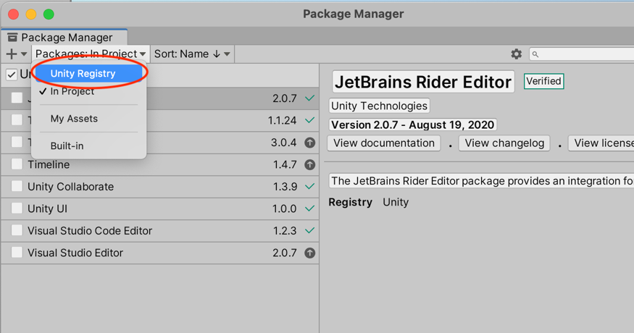

Go to the search bar and enter “Recorder” to find the Unity Recorder package. Then press **Install** to install the package.

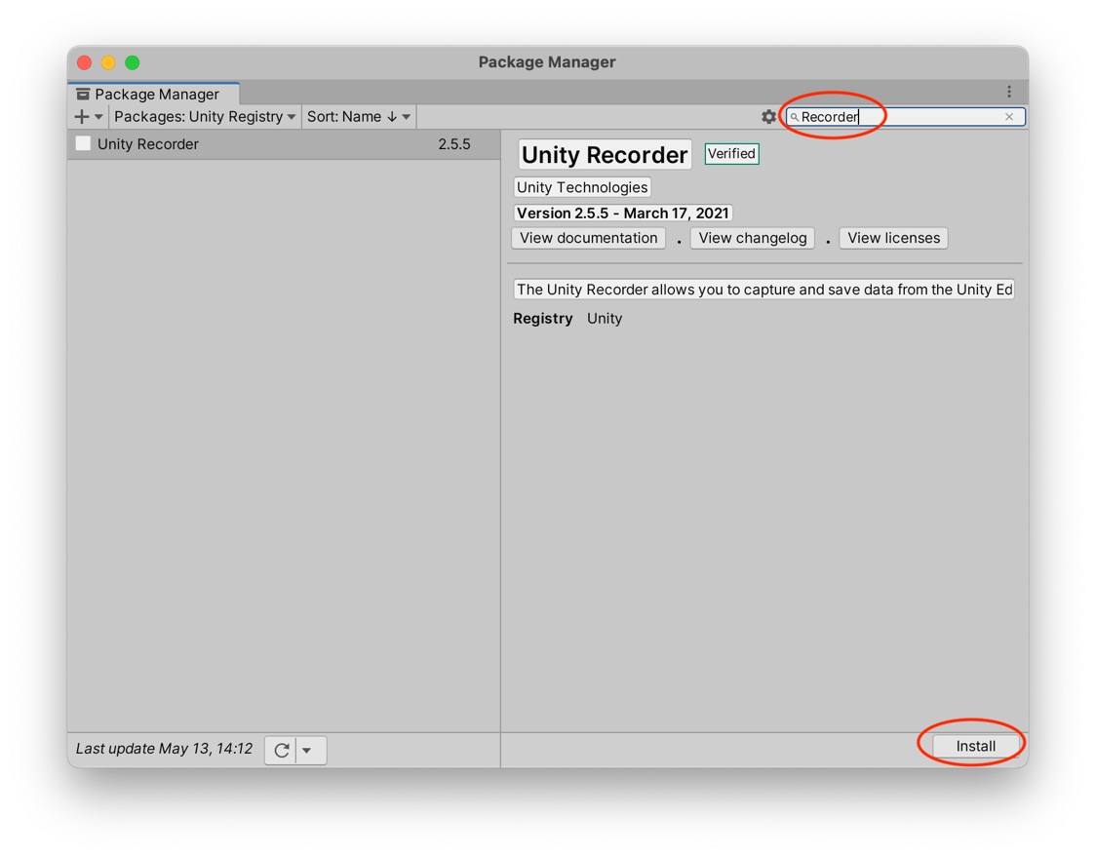

Once the Recorder package is installed, you have some new menu items under the **Window** -> **General** menu. You can use this to open the Recorder Window:

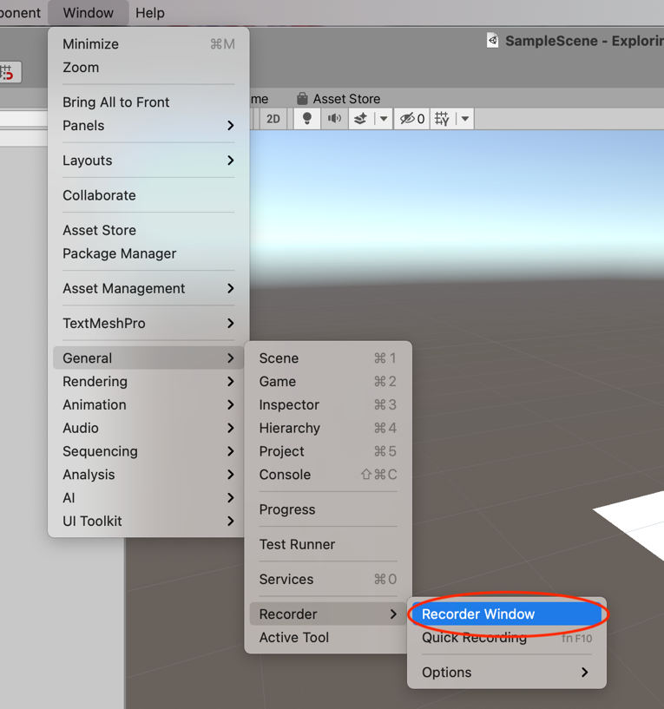

In the Recorder Window, press the **+ Add Recorder** button to add a new recording, and select **Movie** from the drop-down list:

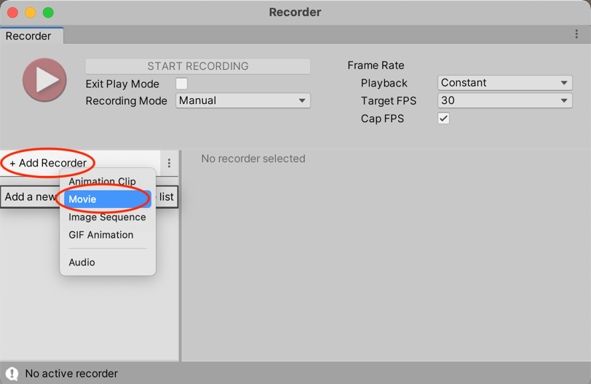

You are now ready to start recording. When you press the Play button, your game will automatically enter play mode and the gameplay (including music) will be recorded.

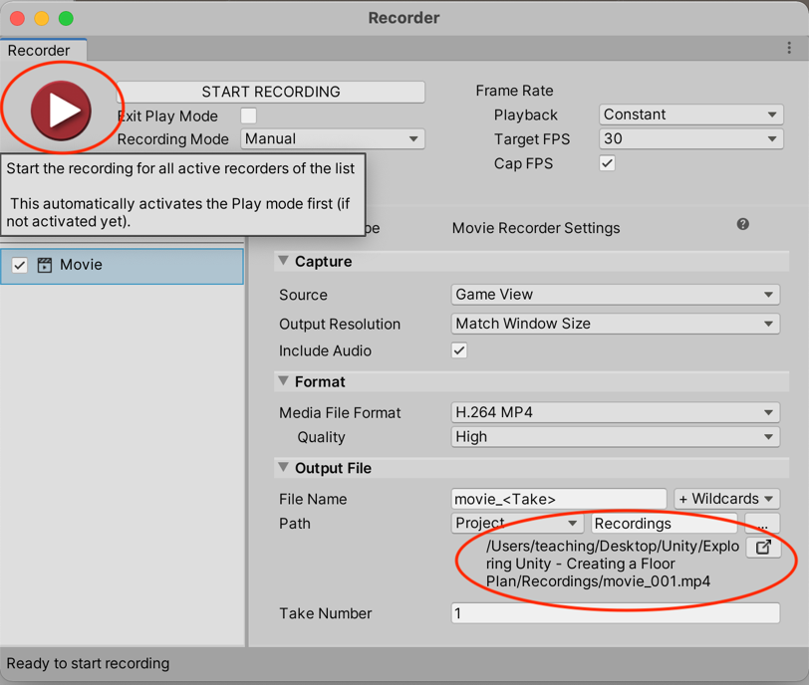

Note the screen also shows you where your video is being stored, and provides a button that will open the movie in the File Explorer so you can copy it or move it.

**Now make a short video (max 10 min) of walking through your game.**

# Publishing Your Game for Submission

In order to submit your game to a learning management system for assessment, it needs to be in a particular format. We use a custom package **Publish for Submission** to create the submission components with a single click.

To install the custom package, go to the Unity Asset Store (<https://assetstore.unity.com>) in your browser, make sure you are logged in, and search for “Publish for Submission”:



Select “Add to My Assets”:



From the Window menu, open the Package Manager. In the drop-down list (where you selected Unity Registry previously), select **My Assets**:

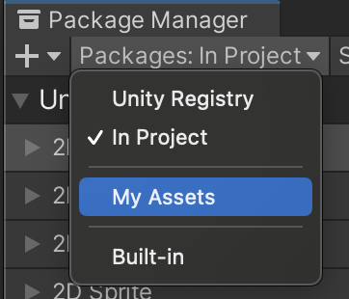

You should see “Publish for Submission” in the list. Select it and press **Import**. Unity will download it and add it to your project.

Now you can do a final check to make sure everything is in the right place. Open up the project in the Explorer. Check you have a **Build** folder with your executable build and a **Recordings** folder with your gameplay videos, and a **Documentation** folder with your game documentation:



Now press **Publish** in the File menu and Unity will automatically create a submission package for you!

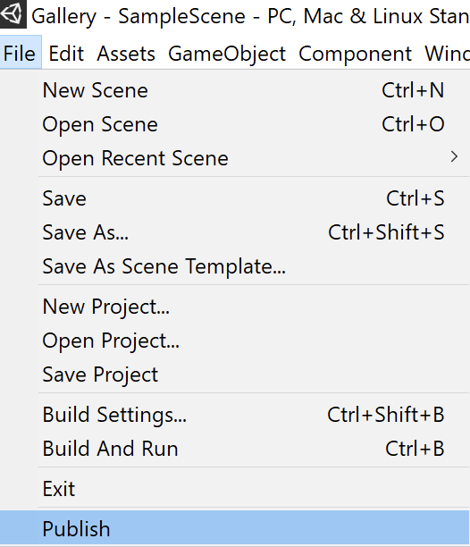

(Any errors and warnings will be shown in the Console window.)

Your items are saved in a folder that is at the same level as your project folder:

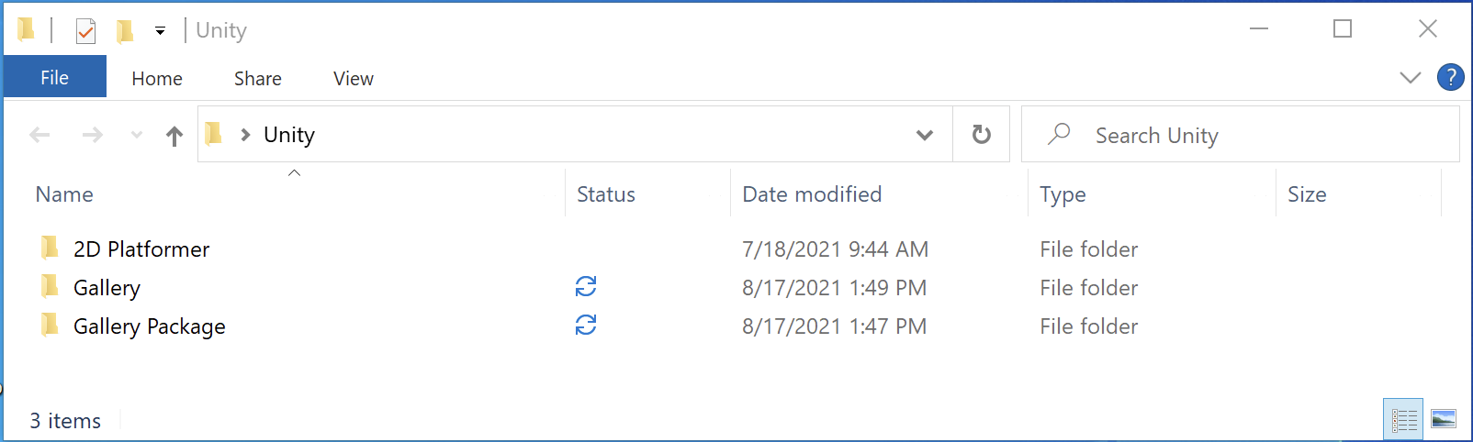

# Uploading a Submission to a Learning Management System

Most Learning Management Systems can parse videos, documents but aren’t able to parse compressed (zipped) files. For this reason, you should load each of the files in your “package” folder separately, rather than as one zipped folder.

We are going to upload three items to our Learning Management System:

* Compressed (zipped) file of the game executable
* Compressed (zipped) file of the game source code
* Gameplay video
* Documentation

For the purposes of this demo, we’ll be using the Teamie LMS (<https://theteamie.com>), but the mechanism should be very similar for your LMS.

First, find the assignment in your LMS and press **Submit**:

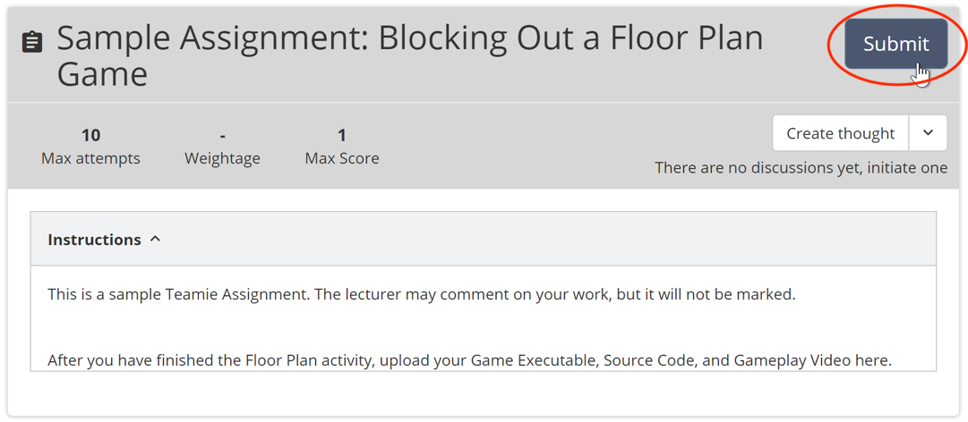

Drag all the files from your Package folder into the File Submission area:

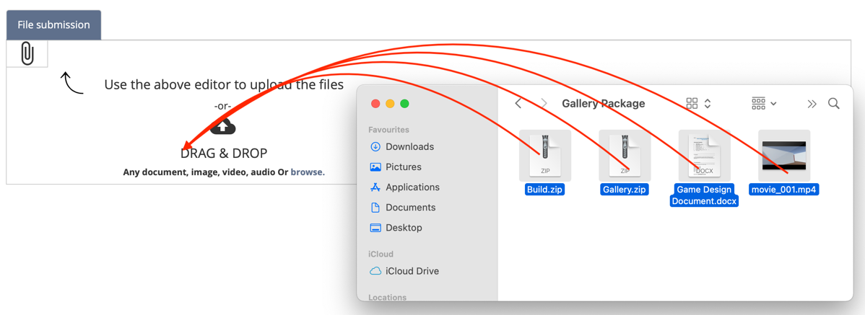

Finally, select **Submit for Evaluation** in the upper-right-hand corner:

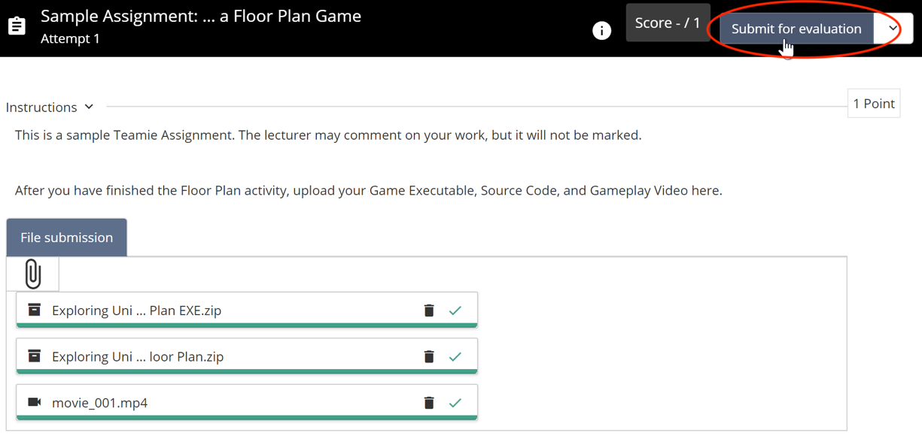

Confirm your submission:

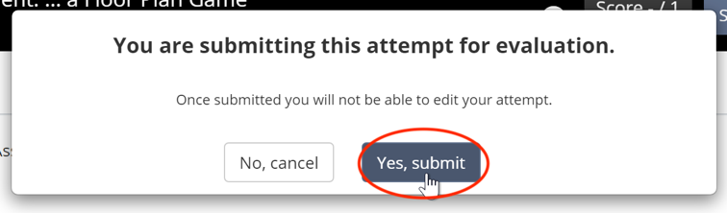

Check with your lecturer that the submission was received properly.

DONE!